**EXPERIMENT 5B**

**NAME: Shivam Pawar UID: 2019230068**

**NAME: Vishal Salvi UID: 2019230069**

**NAME: Shreyas Patel UID: 2018130037**

**CLASS: TE COMPS BATCH: C**

**DATE:**

**Aim**: To develop app for mobile device

**Theory:**

**Prob Definition:**

We are implementing Music Stream Application, this application help to listen music from external storage. User can listen music without internet access as well as can downloaded music can also added in this application.

User can Paused at any time, Listen Next as well as previous song.

**Screen Shots**

**Application allow user to access photos, media and files from mobile device.**

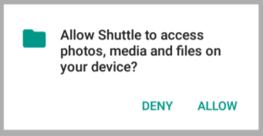

**After that list is display on the screen. Following are the music which are form external device storage.**

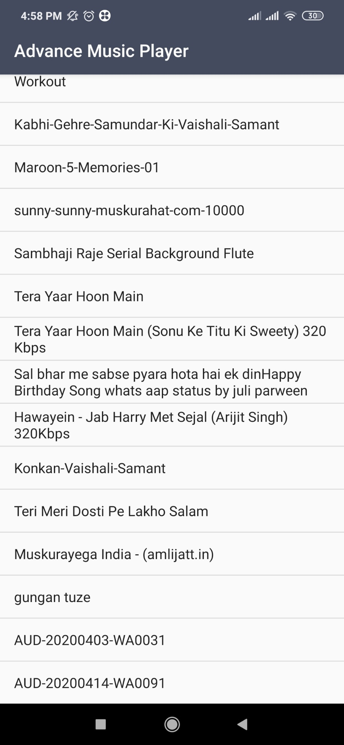

**User can select any song from application and listen.**

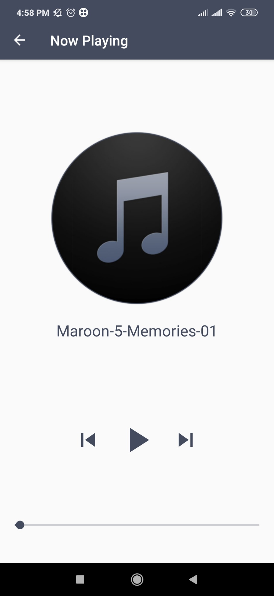

**User can move Seekbar and listen on different time position.**

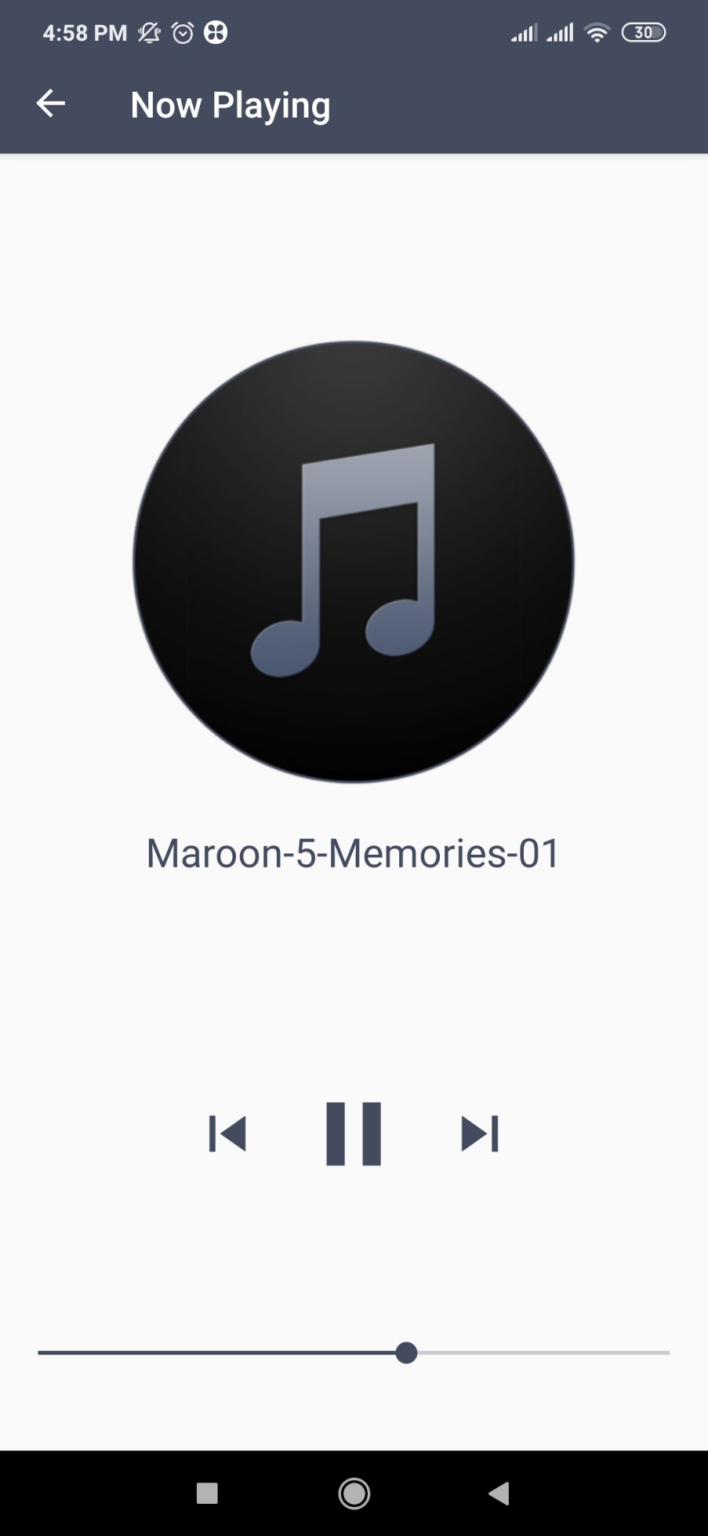

**User can stop song(Paused)**

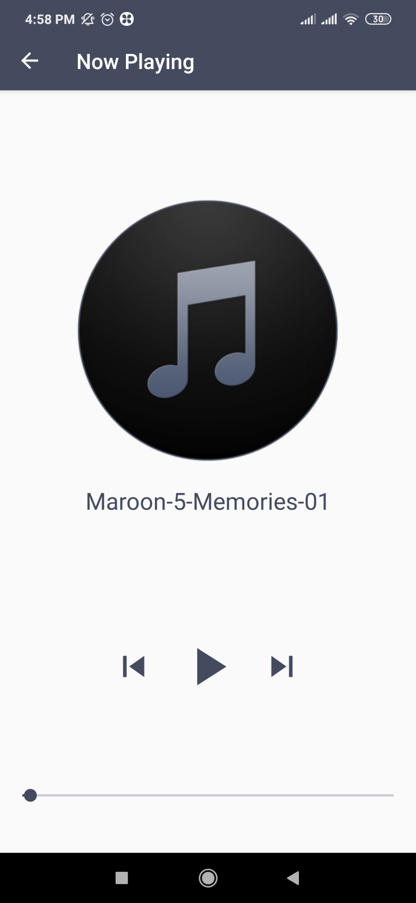

**User can again play song**

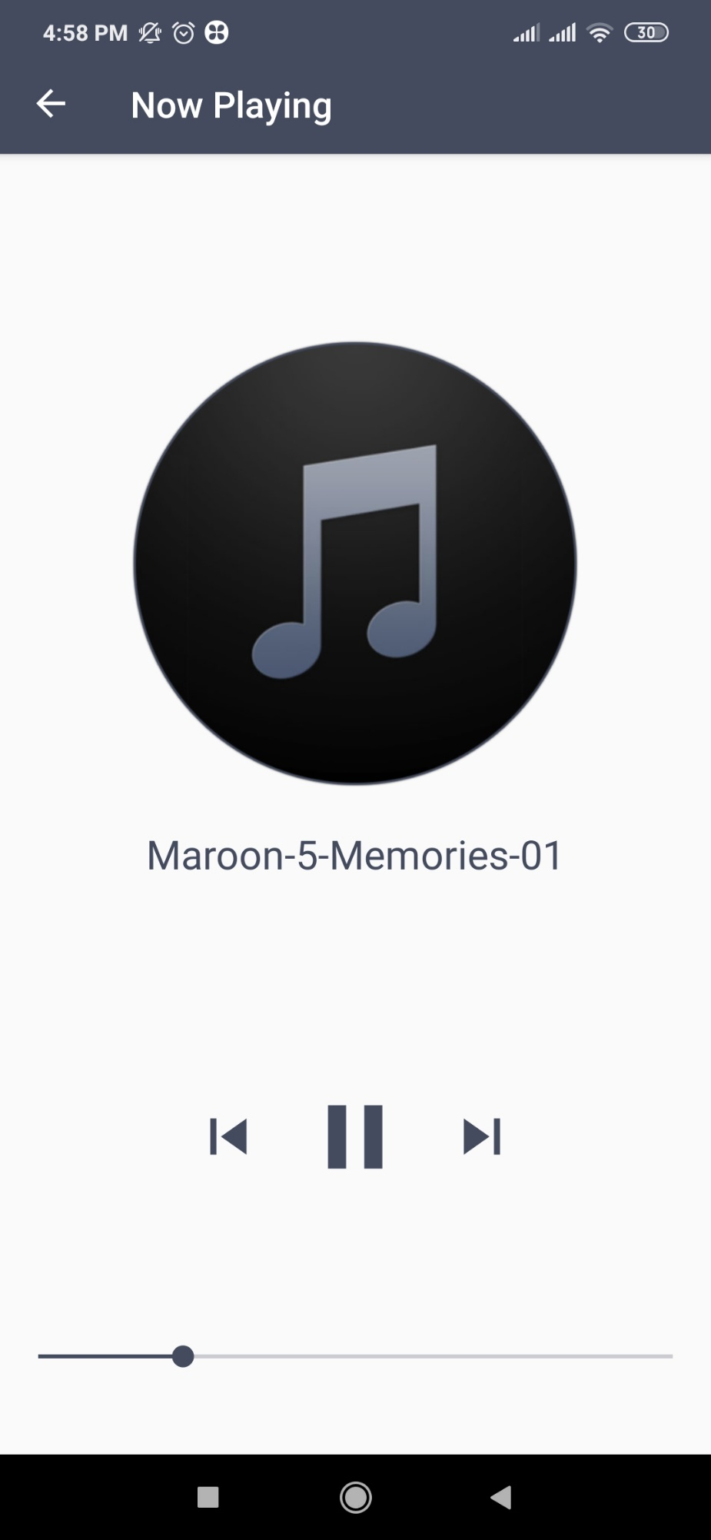

**User can click on next arrow to listen next song.**

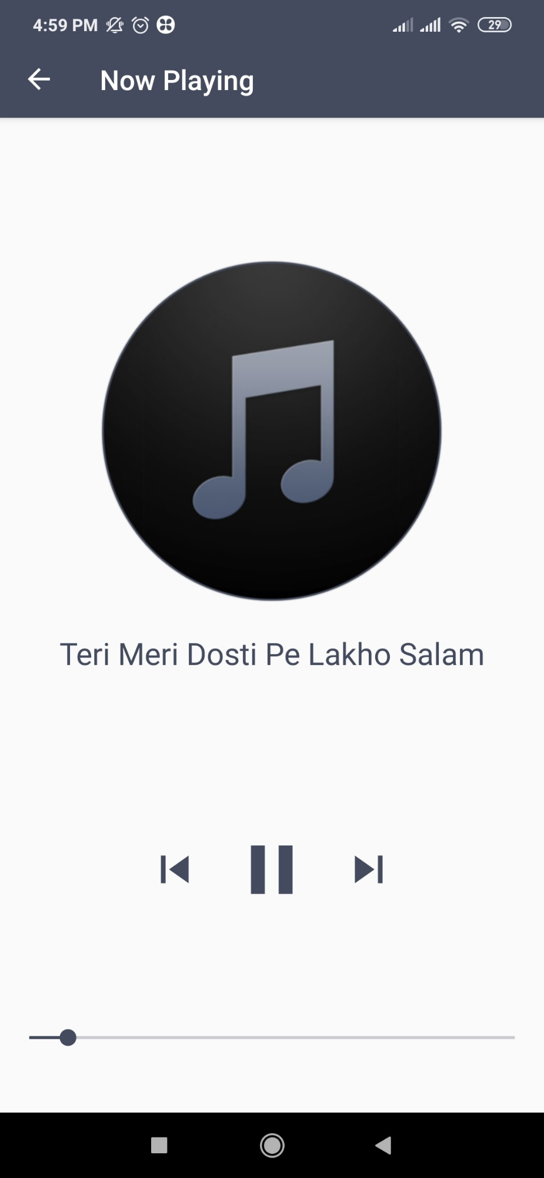

**User can click on Back arrow to listen Previous song.**

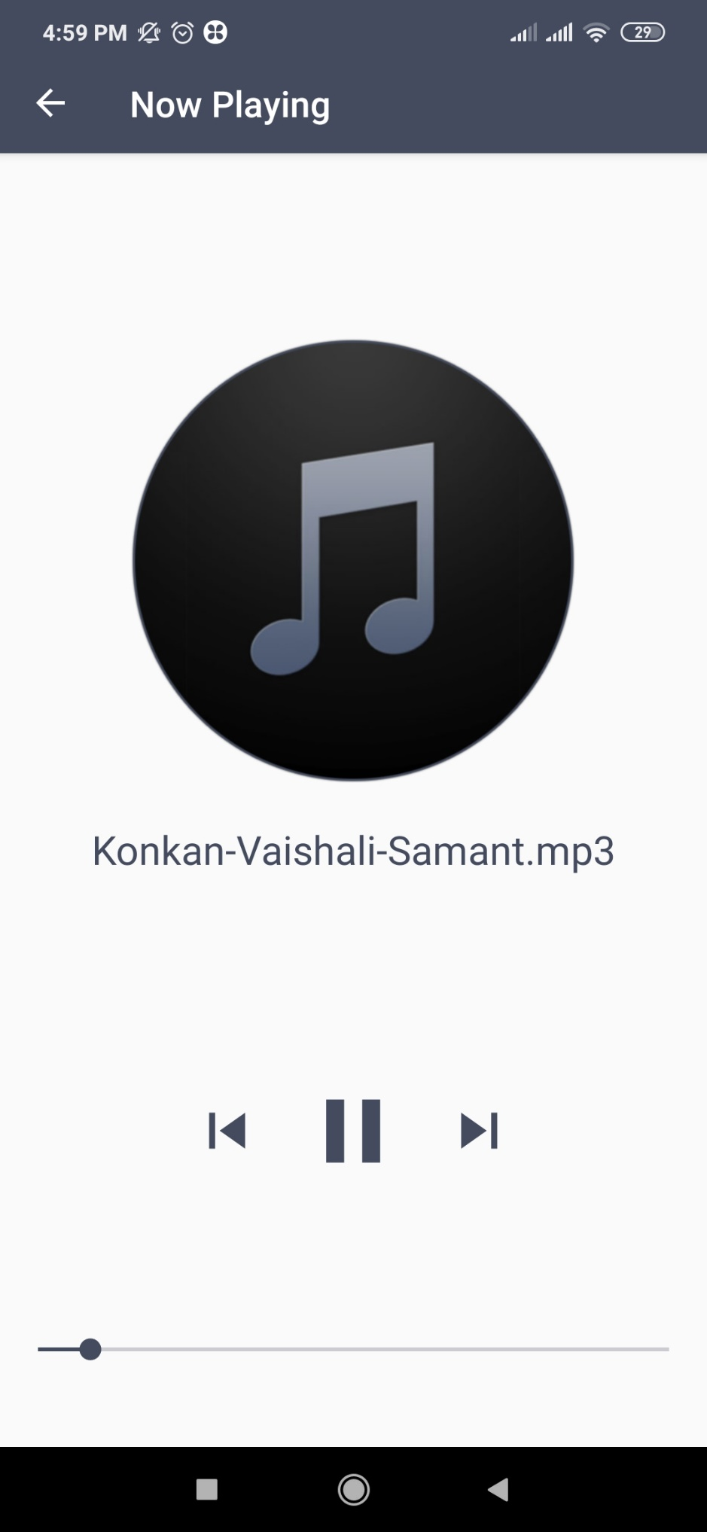

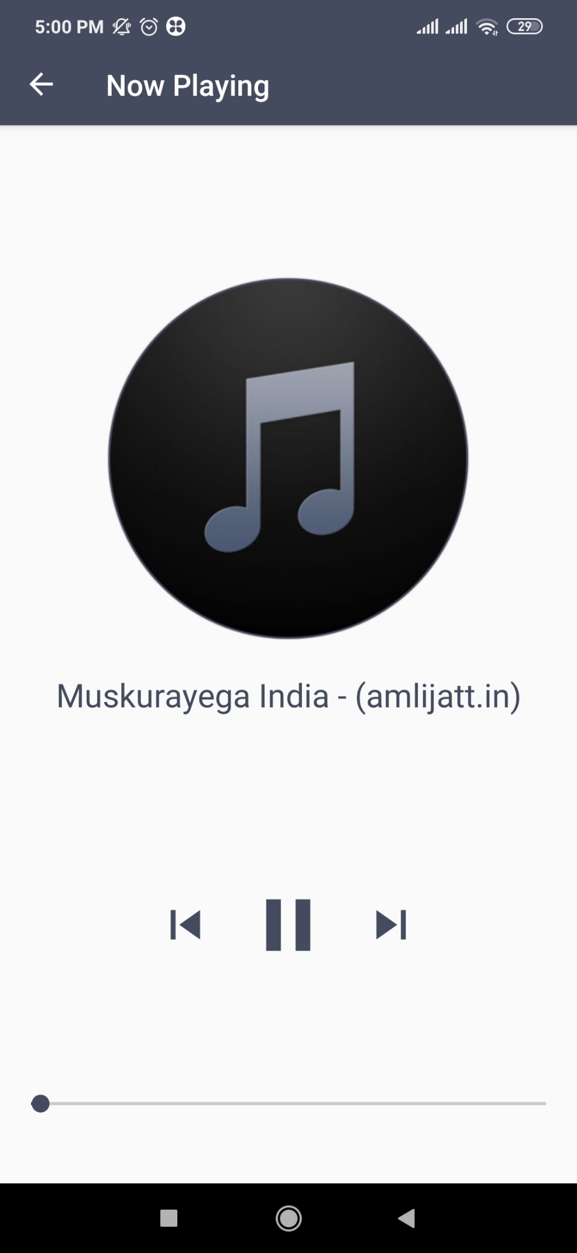

**User can adjust Volume (Low)**

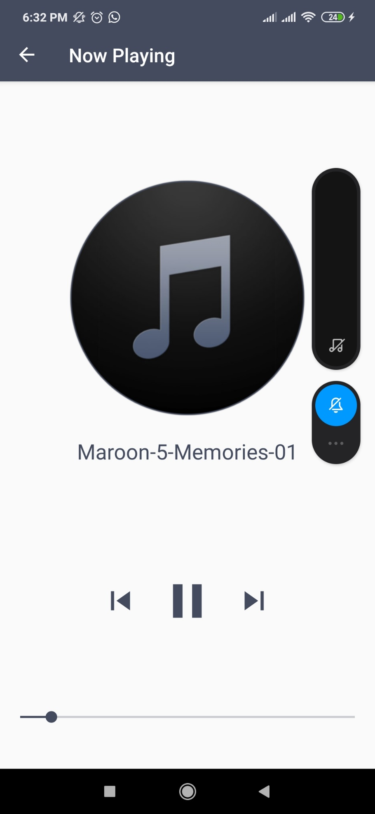

**Volume High**

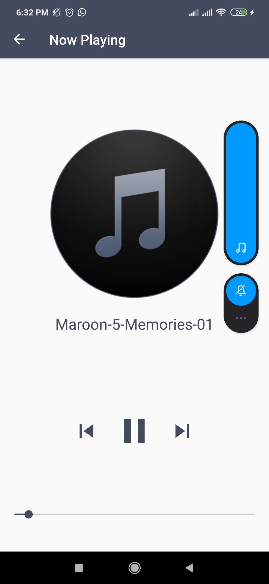

**Working Recording:**

<https://drive.google.com/folderview?id=1MD1oJ6XcYTQaJ1k_lUItEVwaOxPtASoN>

**Code Snippet:**

**activity_main.xml**

*<?***xml version="1.0" encoding="utf-8"***?>*<**RelativeLayout xmlns:android="http://schemas.android.com/apk/res/android"  
 xmlns:app="http://schemas.android.com/apk/res-auto"  
 xmlns:tools="http://schemas.android.com/tools"  
 android:layout_width="match_parent"  
 android:layout_height="match_parent"  
 android:padding="15dp"  
 tools:context=".MainActivity"**>  
  
 <**ListView  
 android:id="@+id/mySongListView"  
 android:layout_width="402dp"  
 android:layout_height="722dp"**>  
 </**ListView**>  
  
</**RelativeLayout**>

**MainActivity.java**

**package** com.example.shuttle;  
  
**import** androidx.appcompat.app.AppCompatActivity;  
**import** android.Manifest;  
**import** android.content.Intent;  
**import** android.os.Bundle;  
**import** android.os.Environment;  
**import** android.view.View;  
**import** android.widget.AdapterView;  
**import** android.widget.ArrayAdapter;  
**import** android.widget.ListView;  
**import** com.karumi.dexter.Dexter;  
**import** com.karumi.dexter.PermissionToken;  
**import** com.karumi.dexter.listener.PermissionDeniedResponse;  
**import** com.karumi.dexter.listener.PermissionGrantedResponse;  
**import** com.karumi.dexter.listener.PermissionRequest;  
**import** com.karumi.dexter.listener.single.PermissionListener;  
**import** java.io.File;  
**import** java.util.ArrayList;  
**import** dalvik.system.DexClassLoader;  
  
**public class** MainActivity **extends** AppCompatActivity {  
 ListView **myListViewforSongs**;  
 String[] **items**;  
 @Override  
 **protected void** onCreate(Bundle savedInstanceState) {  
 **super**.onCreate(savedInstanceState);  
 setContentView(R.layout.***activity_main***);  
  
 **myListViewforSongs**=(ListView) findViewById(R.id.***mySongListView***);  
 runtimePermission();  
 }  
  
 **public void** runtimePermission(){  
 Dexter.withActivity(**this**)  
 .withPermission(Manifest.permission.READ_EXTERNAL_STORAGE)  
 .withListener(**new** PermissionListener() {  
 @Override  
 **public void** onPermissionGranted(PermissionGrantedResponse response) {  
  
 display();  
  
 }  
  
 @Override  
 **public void** onPermissionDenied(PermissionDeniedResponse response) {  
  
 }  
  
 @Override  
 **public void** onPermissionRationaleShouldBeShown(PermissionRequest permission, PermissionToken token) {  
 token.continuePermissionRequest();  
  
 }  
 }).check();  
 }  
 **public** ArrayList<File> findSong(File file){  
 ArrayList<File> arrayList=**new** ArrayList<>();  
 File[] files= file.listFiles();  
 **for**(File singleFile: files){  
 **if** (singleFile.isDirectory() && !singleFile.isHidden()) {  
  
 arrayList.addAll(findSong(singleFile));  
 }  
 **else**{  
 **if**(singleFile.getName().endsWith(**".mp3"**) ||  
 singleFile.getName().endsWith(**".wav"**)){  
 arrayList.add(singleFile);  
 }}  
 }  
 **return** arrayList;  
 }  
  
 **void** display(){  
 **final** ArrayList<File> mySongs=findSong(Environment.getExternalStorageDirectory());  
 items=**new** String[mySongs.size()];  
 **for**(**int** i=0;i<mySongs.size();i++){  
 items[i] = mySongs.get(i).getName().toString().replace(**".mp3"**,**""**).replace(**".wav"**,**""**);  
  
 }  
 ArrayAdapter<String> myAdapter= **new** ArrayAdapter<String>(**this**,android.R.layout.simple_list_item_1,items);  
 myListViewforSongs.setAdapter(myAdapter);  
  
 myListViewforSongs.setOnItemClickListener(**new** AdapterView.OnItemClickListener() {  
 @Override  
 **public void** onItemClick(AdapterView<?> adapterView, View view, **int** i, **long** l) {  
  
 String songName = myListViewforSongs.getItemAtPosition(i).toString();  
  
 startActivity(**new** Intent(getApplicationContext(),PlayerActivity.**class**)  
 .putExtra(**"songs"**,mySongs).putExtra(**"songname"**,songName)  
 .putExtra(**"pos"**,i));  
  
  
 }  
  
  
 });  
  
 }  
}

**player_activity.xml**

*<?***xml version="1.0" encoding="utf-8"***?>*<**LinearLayout xmlns:android="http://schemas.android.com/apk/res/android"  
 xmlns:app="http://schemas.android.com/apk/res-auto"  
 xmlns:tools="http://schemas.android.com/tools"  
 android:layout_width="match_parent"  
 android:orientation="vertical"  
 android:weightSum="10"  
 android:layout_height="match_parent"  
 tools:context=".PlayerActivity"**>  
 <**LinearLayout  
 android:layout_width="match_parent"  
 android:layout_height="0dp"  
 android:layout_weight="7"  
 android:orientation="vertical"  
 android:gravity="center"** >  
 <**ImageView  
 android:layout_width="250dp"  
 android:layout_height="250dp"  
 android:src="@drawable/music"** />  
  
 <**TextView  
 android:id="@+id/songLabel"  
 android:layout_width="match_parent"  
 android:layout_height="wrap_content"  
 android:layout_marginTop="20dp"  
 android:ellipsize="marquee"  
 android:marqueeRepeatLimit="marquee_forever"  
 android:scrollHorizontally="true"  
 android:singleLine="true"  
 android:text="Song Name"  
 android:textColor="#000000"  
 android:textAlignment="center"  
 android:textStyle="bold"  
 android:textSize="30sp"** />  
  
  
 </**LinearLayout**>  
 <**LinearLayout  
 android:layout_width="match_parent"  
 android:layout_height="0dp"  
 android:layout_weight="3"**>  
 <**RelativeLayout  
 android:layout_width="match_parent"  
 android:layout_height="match_parent"  
 android:padding="5dp"**>  
 <**SeekBar  
 android:layout_width="match_parent"  
 android:layout_height="wrap_content"  
 android:id="@+id/seekbar"  
 android:layout_alignParentBottom="true"  
 android:layout_marginBottom="40dp"** />  
 <**Button  
 android:layout_width="60dp"  
 android:layout_height="60dp"  
 android:layout_centerHorizontal="true"  
 android:background="@drawable/icon_pause"  
 android:id="@+id/pause"  
 android:layout_marginTop="5dp"** />  
  
 <**Button  
 android:id="@+id/next"  
 android:layout_width="40dp"  
 android:layout_height="40dp"  
 android:layout_marginLeft="45dp"  
 android:layout_marginTop="15dp"  
 android:layout_toRightOf="@+id/pause"  
 android:background="@drawable/icon_next"**/>  
  
 <**Button  
 android:id="@+id/previous"  
 android:layout_width="40dp"  
 android:layout_height="40dp"  
 android:layout_marginLeft="45dp"  
 android:layout_marginTop="15dp"  
 android:layout_marginRight="45dp"  
 android:layout_toLeftOf="@+id/pause"  
 android:background="@drawable/icon_previous"** />  
 </**RelativeLayout**>  
 </**LinearLayout**>  
</**LinearLayout**>

**PlayerActivity.java**

**package** com.example.shuttle;  
**import** androidx.annotation.NonNull;  
**import** androidx.appcompat.app.AppCompatActivity;  
**import** android.annotation.SuppressLint;  
**import** android.content.Intent;  
**import** android.graphics.PorterDuff;  
**import** android.media.MediaPlayer;  
**import** android.net.Uri;  
**import** android.os.Bundle;  
**import** android.view.MenuItem;  
**import** android.view.View;  
**import** android.widget.Button;  
**import** android.widget.SeekBar;  
**import** android.widget.TextView;  
**import** java.io.File;  
**import** java.util.ArrayList;  
**import static** android.graphics.PorterDuff.Mode.***SRC_IN***;  
**public class** PlayerActivity **extends** AppCompatActivity {  
 Button **btn_next**, **btn_previous**, **btn_pause**;  
 TextView **songText**;  
 SeekBar **songSeekBar**;  
 String **sname**;  
 **static** MediaPlayer *myMediaPlayer*;  
 **int position**;  
 ArrayList<File> **mySongs**;  
 Thread **updateseekbar**;  
  
 @SuppressLint(**"NewApi"**)  
 @Override  
 **protected void** onCreate(Bundle savedInstanceState) {  
 **super**.onCreate(savedInstanceState);  
 setContentView(R.layout.***activity_player***);  
 **btn_next** = (Button) findViewById(R.id.***next***);  
 **btn_previous** = (Button) findViewById(R.id.***previous***);  
 **btn_pause** = (Button) findViewById(R.id.***pause***);  
 **songText** = (TextView) findViewById(R.id.***songLabel***);  
 **songSeekBar** = (SeekBar) findViewById(R.id.***seekbar***);  
 getSupportActionBar().setTitle(**"Now Playing"**);  
 getSupportActionBar().setDisplayHomeAsUpEnabled(**true**);  
 getSupportActionBar().setDisplayShowHomeEnabled(**true**);  
 **updateseekbar** = **new** Thread() {  
 **public void** run() {  
 **int** totalDuration = *myMediaPlayer*.getDuration();  
 **int** currentPosition = 0;  
 **while** (currentPosition < totalDuration) {  
 **try** {  
 *sleep*(500);  
 currentPosition = *myMediaPlayer*.getCurrentPosition();  
 **songSeekBar**.setProgress(currentPosition);  
 } **catch** (InterruptedException e) {  
 e.printStackTrace();  
 }  
  
 }  
  
 }  
 };  
 **if** (*myMediaPlayer* != **null**) {  
 *myMediaPlayer*.stop();  
 *myMediaPlayer*.release();  
  
 }  
 Intent i = getIntent();  
 Bundle bundle = i.getExtras();  
 **mySongs** = (ArrayList) bundle.getParcelableArrayList(**"songs"**);  
 **sname** = **mySongs**.get(**position**).getName().toString();  
 String songName = i.getStringExtra(**"songname"**);  
 **songText**.setText(songName);  
 **songText**.setSelected(**true**);  
 **position** = bundle.getInt(**"pos"**, 0);  
 Uri u = Uri.*parse*(**mySongs**.get(**position**).toString());  
 *myMediaPlayer* = MediaPlayer.*create*(getApplicationContext(), u);  
 *myMediaPlayer*.start();  
 **songSeekBar**.setMax(*myMediaPlayer*.getDuration());  
 **updateseekbar**.start();  
 **songSeekBar**.getProgressDrawable().setColorFilter(getResources().getColor(R.color.***colorPrimary***), PorterDuff.Mode.***MULTIPLY***);  
 **songSeekBar**.getThumb().setColorFilter(getResources().getColor(R.color.***colorPrimary***), PorterDuff.Mode.***SRC_IN***);  
 **songSeekBar**.setOnSeekBarChangeListener(**new** SeekBar.OnSeekBarChangeListener() {  
 @Override  
 **public void** onProgressChanged(SeekBar seekBar, **int** i, **boolean** b) {  
  
 }  
  
 @Override  
 **public void** onStartTrackingTouch(SeekBar seekBar) {  
  
 }  
  
 @Override  
 **public void** onStopTrackingTouch(SeekBar seekBar) {  
 *myMediaPlayer*.seekTo(seekBar.getProgress());  
  
 }  
 });  
  
 **btn_pause**.setOnClickListener(**new** View.OnClickListener() {  
 @Override  
 **public void** onClick(View view) {  
 **songSeekBar**.setMax(*myMediaPlayer*.getDuration());  
 **if** (*myMediaPlayer*.isPlaying()) {  
 **btn_pause**.setBackgroundResource(R.drawable.***icon_play***);  
 *myMediaPlayer*.pause();  
 } **else** {  
 **btn_pause**.setBackgroundResource(R.drawable.***icon_pause***);  
 *myMediaPlayer*.start();  
 }  
 }  
 });  
 **btn_next**.setOnClickListener(**new** View.OnClickListener() {  
 @Override  
 **public void** onClick(View view) {  
 *myMediaPlayer*.stop();  
 *myMediaPlayer*.release();  
 **position** = ((**position** + 1) % **mySongs**.size());  
 Uri u = Uri.*parse*(**mySongs**.get(**position**).toString());  
 *myMediaPlayer* = MediaPlayer.*create*(getApplicationContext(), u);  
 **sname** = **mySongs**.get(**position**).getName().toString();  
 **songText**.setText(**sname**);  
 *myMediaPlayer*.start();  
 }  
 });  
 **btn_previous**.setOnClickListener(**new** View.OnClickListener() {  
 @Override  
 **public void** onClick(View view) {  
 *myMediaPlayer*.stop();  
 *myMediaPlayer*.release();  
  
 **position** = ((**position** - 1) < 0) ? (**mySongs**.size()) - 1 : (**position** - 1);  
 Uri u = Uri.*parse*(**mySongs**.get(**position**).toString());  
 *myMediaPlayer* = MediaPlayer.*create*(getApplicationContext(), u);  
 **sname** = **mySongs**.get(**position**).getName().toString();  
 **songText**.setText(**sname**);  
 *myMediaPlayer*.start();  
  
 }  
 });  
 }  
  
 @Override  
 **public boolean** onOptionsItemSelected(@NonNull MenuItem item) {  
 **if** (item.getItemId() == android.R.id.***home***) {  
 onBackPressed();  
 }  
 **return super**.onOptionsItemSelected(item);  
 }  
}

**dependencies:**

dependencies {  
 implementation fileTree(**dir**: **'libs'**, **include**: [**'*.jar'**])  
 implementation **'androidx.appcompat:appcompat:1.0.2'** implementation **'androidx.constraintlayout:constraintlayout:1.1.3'** testImplementation **'junit:junit:4.12'** androidTestImplementation **'androidx.test:runner:1.2.0'** androidTestImplementation **'androidx.test.espresso:espresso-core:3.2.0'** implementation **'com.karumi:dexter:6.0.0'**}

**AndroidManifest.xml**

*<?***xml version="1.0" encoding="utf-8"***?>*<**manifest xmlns:android="http://schemas.android.com/apk/res/android"  
 package="com.example.shuttle"**>  
 <**uses-permission android:name="android.permission.READ_EXTERNAL_STORAGE"**/>  
  
  
 <**application  
 android:allowBackup="true"  
 android:icon="@mipmap/ic_launcher"  
 android:label="@string/app_name"  
 android:roundIcon="@mipmap/ic_launcher_round"  
 android:supportsRtl="true"  
 android:theme="@style/AppTheme"**>  
 <**activity android:name=".PlayerActivity"**></**activity**>  
 <**activity android:name=".MainActivity"**>  
 <**intent-filter**>  
 <**action android:name="android.intent.action.MAIN"** />  
  
 <**category android:name="android.intent.category.LAUNCHER"** />  
 </**intent-filter**>  
 </**activity**>  
 </**application**>  
  
</**manifest**>

**Conclusion:**

**Thus From this experiment we built Music Stream Application.**